## Day 2 Activity File: Filebeat Installation

By the end of class today, you should complete the following steps:

1. **Install Filebeat on the DVWA container**. Verify your ELK server container is up and running, and install Filebeat.

2. **Create the Filebeat configuration file**. Create and edit the Filebeat configuration file for your DVWA VMs.

3. **Create the Filebeat installation play**. Create another Ansible playbook that accomplishes the tasks listed below.

4. **Verify the installation and playbook**. Confirm that your installation and playbook worked by verifying that the ELK stack is receiving logs.

---

### Instructions

#### 1. Installing Filebeat on the DVWA Container

First, make sure that the ELK server container is up and running:

- Navigate to http://[your.VM.IP]:5601. Use the public IP address of the ELK server that you created.

Screenshot enclosed

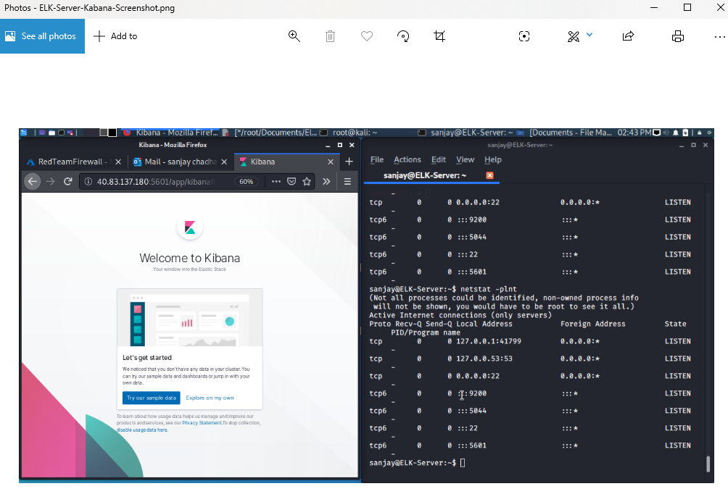

- If you do not see the ELK server landing page, open a terminal on your computer and SSH into the ELK server.

- Run `docker container list -a` to verify that the container is on.

- If it isn't, run `docker start sebp/elk`.

Evidence of sebp/elk included

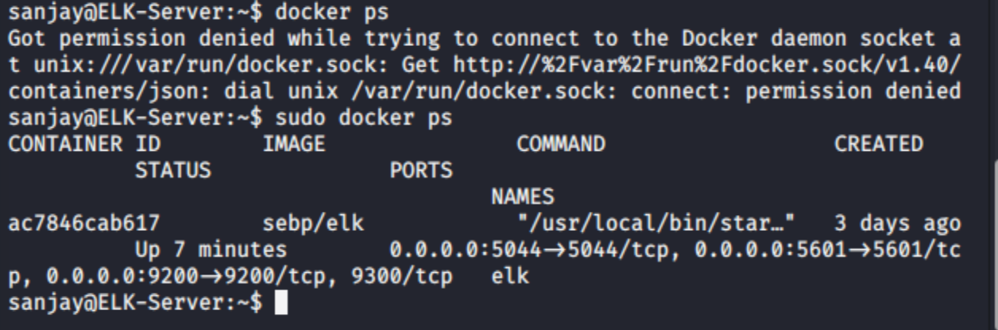

Next, use the ELK server's GUI to begin installing Filebeat on your DVWA VM.

Navigate to your ELK server's IP address:

- Click **Add Log Data**.

- Choose **System Logs**.

- Click on the **DEB** tab under **Getting Started**.

Here you will find the most up-to-date Filebeat installation instructions for Linux.

![](Images/Filebeat.png)

- Note that you do not need to do anything on this page. Since Filebeat is open source, it is updated frequently. Therefore, specific details around installation can change. This site will always have the most up-to-date instructions.

#### 2. Creating the Filebeat Configuration File

Next, we will create a Filebeat configuration file, after which we will create the Ansible playbook file.

At that point, we will translate the instructions in the DEB tab into a new Ansible play, which you will use to automatically install Filebeat on your DVWA machines.

- Translating installation instructions to reusable playbooks is a common task for modern infrastructure teams. Being able to explain the value of this task and the plays you've created will be valuable in job interviews.

- Creating this play will allow you to easily install Filebeat on any machine you want to monitor later, whether for class, work, or a personal project.

Open a terminal and SSH into your jump box:

- Start the Ansible container.

- SSH into the Ansible container.

As mentioned earlier, the Filebeat installation instructions require you to create a Filebeat configuration file.

- You will need to edit this file so that it has the correct settings to work with your ELK server.

You can use the provided template for the Filebeat configuration file:

[Filebeat Configuration File Template](Resources/filebeat-configuration.yml).

Edit this file as specified in the Filebeat instructions (the specific steps are also detailed below).

- The username is `elastic` and the password is `changeme`.

- Scroll to line #1106 and replace the IP address with the IP address of your ELK machine.

Control W then Control T then 1106

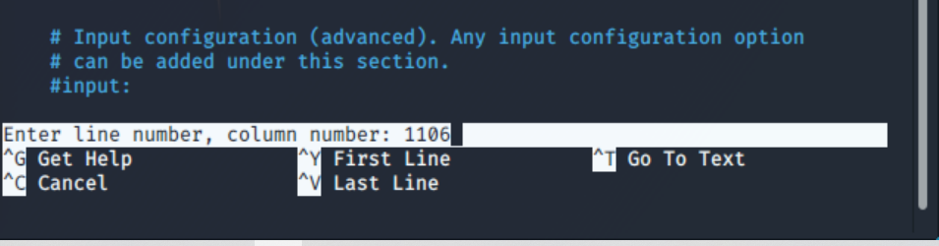

```bash

output.elasticsearch:

hosts: ["10.0.0.12:9200"]

username: "elastic"

password: "changeme"

```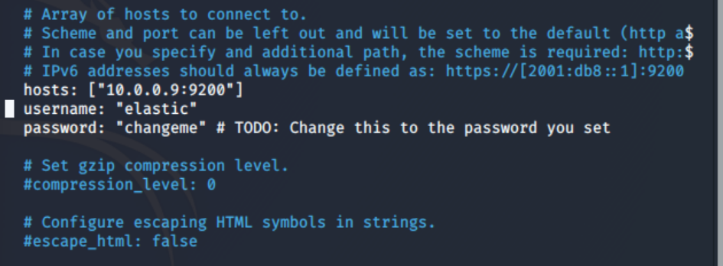

- Scroll to line #1806 and replace the IP address with the IP address of your ELK machine.

```

setup.kibana:

host: "10.0.0.12:5601"

```

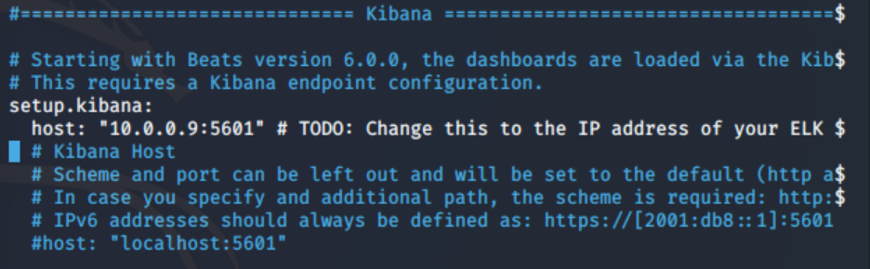

- Note that the default credentials are `elastic:changeme` and should not be changed at this step.

- Save this file in `/etc/ansible/files/filebeat-configuration.yml`.

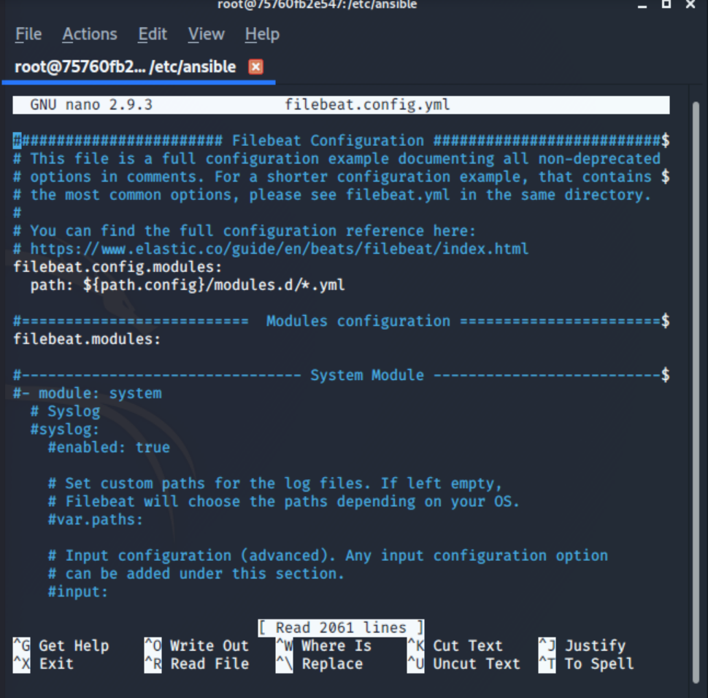

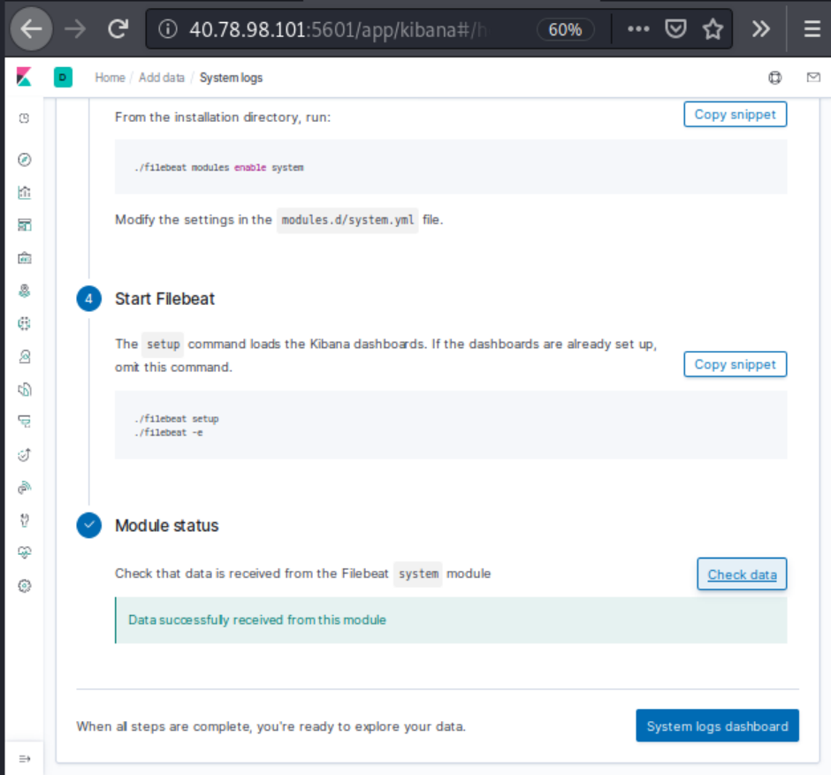

#### 3. Creating the Filebeat Installation Play

Next, create a new playbook that copies the configuration file you just made to the DVWA VMs, and then installs Filebeat.

- On the Ansible VM, create a playbook file, `filebeat-playbook.yml`.

- Locate this file in your `/etc/ansible/roles/` directory.

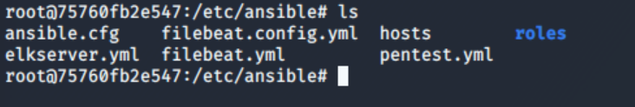

- Open your playbook and implement the following tasks:

- Download the `.deb` file from [artifacts.elastic.co](https://artifacts.elastic.co/downloads/beats/filebeat/filebeat-7.4.0-amd64.deb).

- Install the `.deb` file using the `dpkg` command shown below:

- `dpkg -i filebeat-7.4.0-amd64.deb`

- Copy the Filebeat configuration file from your Ansible container to your ELK VM.

- Use Ansible's `copy` module to copy the entire configuration file to the correct place.

- Run the following commands:

- `./filebeat modules enable system`

- `./filebeat setup`

- `./filebeat -e`

You may find the following hints and links helpful:

- This play should only run on the DVWA machines. Create a new block with `hosts: webservers`. Refer to the [Ansible playbook documentation](https://docs.ansible.com/ansible/latest/user_guide/playbooks_intro.html#playbooks-intro) for an example.

- Use the `copy` module to move `filebeat-configuration.yml` onto the DVWA VMs.

- You can use the `command` module to run `curl`, `dpkg`, and Filebeat commands.

- Use `curl -O` or `curl -o` to download the `dpkgf` file.

- Note the following about the `./filebeat` command:

- The Filebeat installation instructions recommend running commands like `./filebeat modules enable system`.

- Since you installed Filebeat using `dpkg`, you can remove the `./` and run `filebeat modules enable system`.

- This is helpful because it means you can use the `command` module to perform all the steps in a single command: `filebeat modules enable system && filebeat setup && filebeat -e`.

**Note:** You can use the following template for configuring the Filebeat playbook: [Filebeat Playbook Template](Resources/filebeat-playbook.yml). You can also build your own if you'd like an additional challenge.

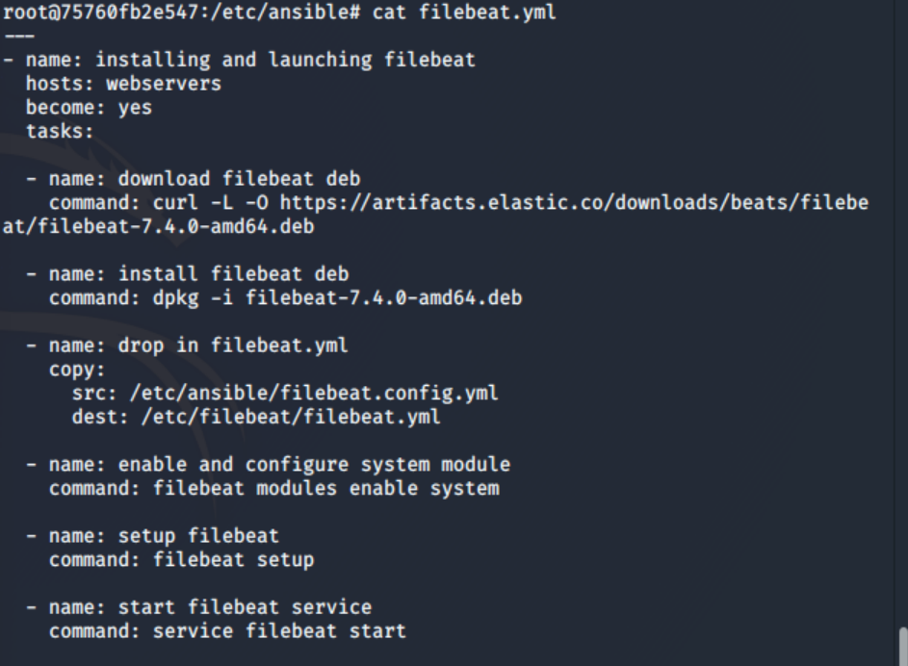

After you create and save this file, run it to install Filebeat on the DVWA machines.

#### 4. Verifying Installation and Playbook

After the playbook completes, follow the steps below to confirm that the ELK stack is receiving logs from your DVWA machines:

- Navigate back to the Filebeat installation page on the ELK server GUI.

- On the same page, scroll to **Step 5: Module Status** and click **Check Data**.

- Scroll to the bottom of the page and click **Verify Incoming Data**.

If your installation was successful, take a screenshot of what you see before proceeding.



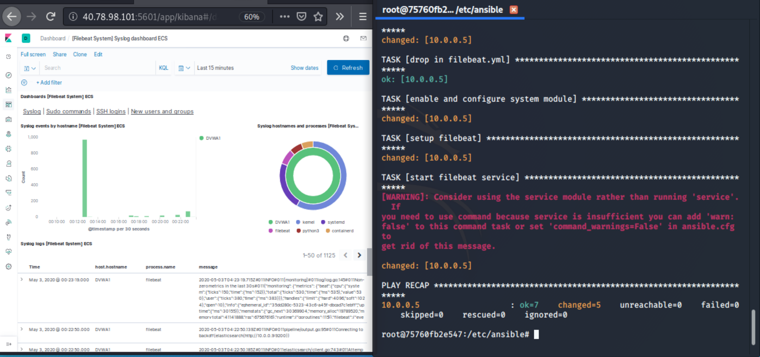

### Day 2 Milestone

If your ELK server is receiving logs, congratulations! You've successfully deployed a live, functional ELK stack and now have plays that can:

- Install and launch Docker containers on a host machine.

- Configure and deploy an ELK server.

- Install Filebeat on any Debian-flavored Linux server.

Even more significant is that you've done all of this through automation with Ansible. Now you can recreate exactly the same setup in minutes.

If you have time, create a play to install Metricbeat. After this, you'll have programmed plays to automatically install 25% of the most common Beats.

#### Bonus: Creating a Play to Install Metricbeat

Note that there are fewer instructions and setup files provided here. However, the process is similar to the one used for the Filebeat installation.

Navigate to your ELK server's IP.

- Click **Add Metric Data**.

- Click **Docker Metrics**.

- Click the **DEB** tab under **Getting Started** for the correct Linux instructions.

![](Images/Metricbeat.png)

Return to your Ansible VM. Update your playbook with tasks that perform the following:

- Download the [Metricbeat `.deb` file](https://artifacts.elastic.co/downloads/beats/metricbeat/metricbeat-7.4.0-amd64.deb).

- Use `dpkg` to install the `.deb` file.

- Update and copy the provided [Metricbeat config file](Resources/metricbeat.yml).

- Run the `./metricbeat modules enable docker` command.

- Run the `./metricbeat setup` command.

- Run the `./metricbeat -e` command.

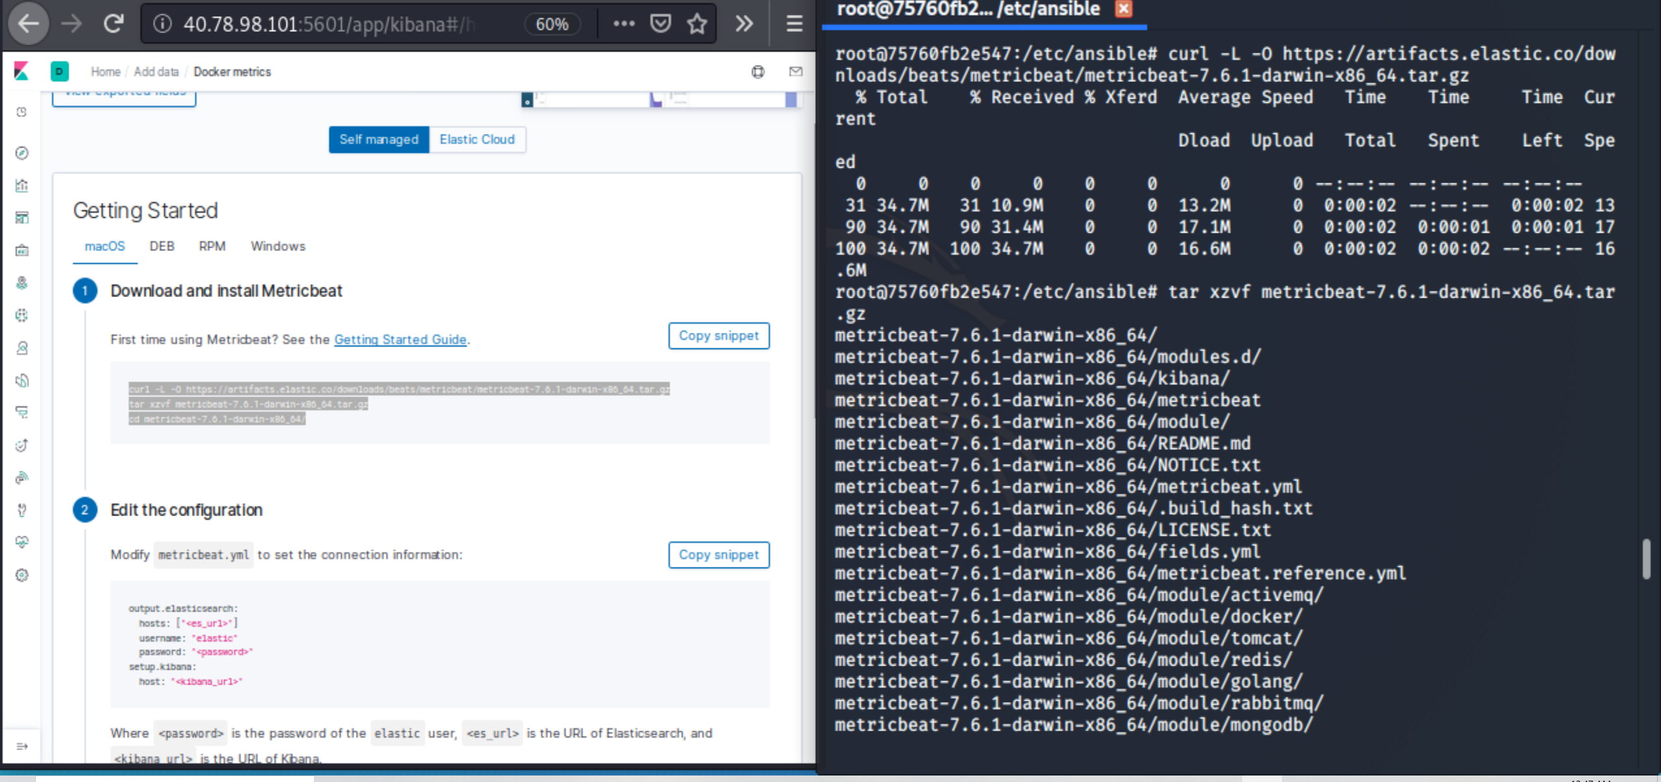

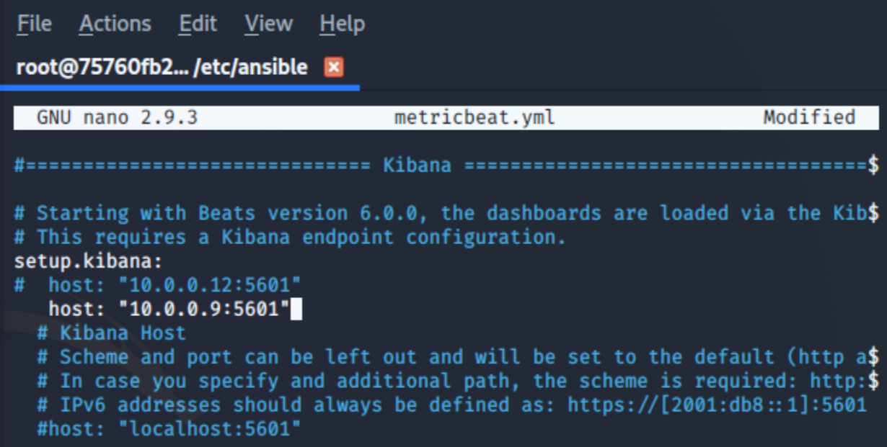

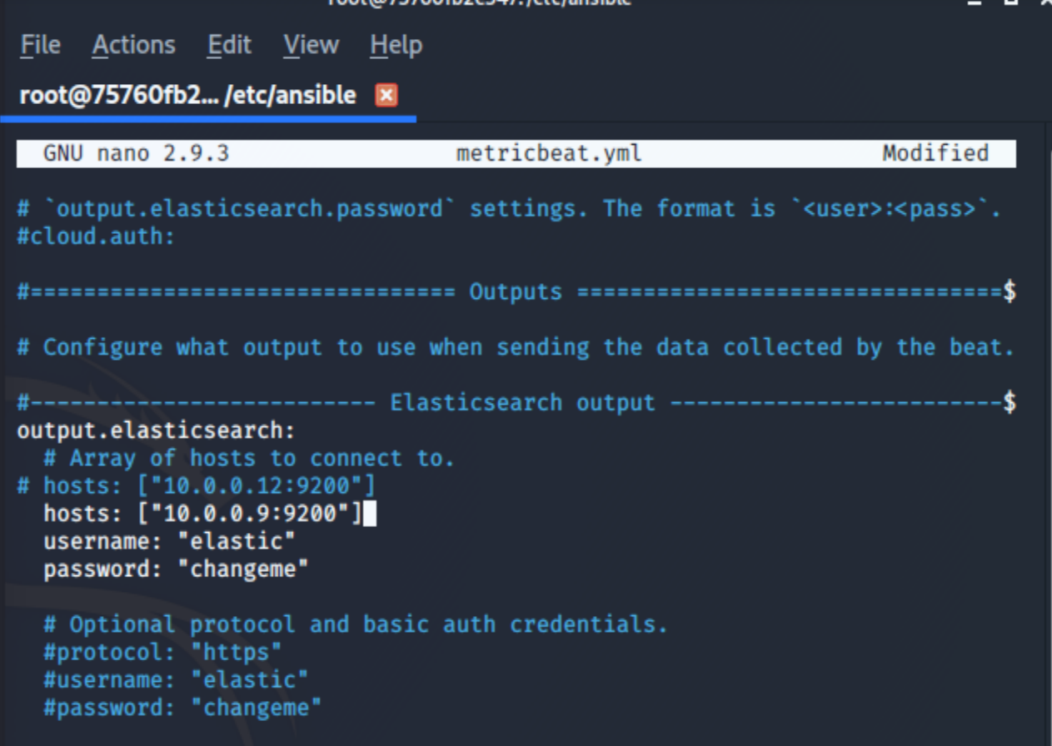

Verify that your play works as expected:

- On the Metricbeat Installation Page in the ELK server GUI, scroll to **Step 5: Module Status** and click **Check Data**.

If your installation was successful, take a screenshot of what you see before proceeding.

---

Â© 2020 Trilogy Education Services, a 2U, Inc. brand. All Rights Reserved.

